## EXP NO:1 C PROGRAM FOR ARRAY OF STRUCTURE TO CHECK ELIGIBILITY FOR THE VACCINE.

### Aim:

To write a C program for array of structure to check eligibility for the vaccine person age above 6 years of age.

### Algorithm:

1. Declare structure eligible with age (integer) and n (character array)
2. Declare variable e of type eligible
3. Input age and name using scanf, store in e
4. If e.age <= 6
   * Print "Vaccine Eligibility: No"

Else

* + Print "Vaccine Eligibility: Yes"

1. Print details (e.age, e.n)
2. Return 0

Program:

#include<stdio.h> struct eligib

{

int age; char n[4];

};

int main()

{

struct eligib e; scanf("%d%s",&e.age,e.n);

if(e.age<=6)

{

printf("Age:%d\nName:%svaccine:%d\neligibility:no",e.age,e.n,e.age);

}

else

{

}

}

printf("Age:%d\nName:%svaccine:%d\neligibility:yes",e.age,e.n,e.age);

### Output:

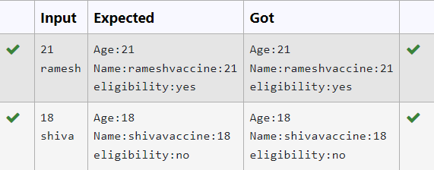

**Result:**

Thus, the program is verified successfully.